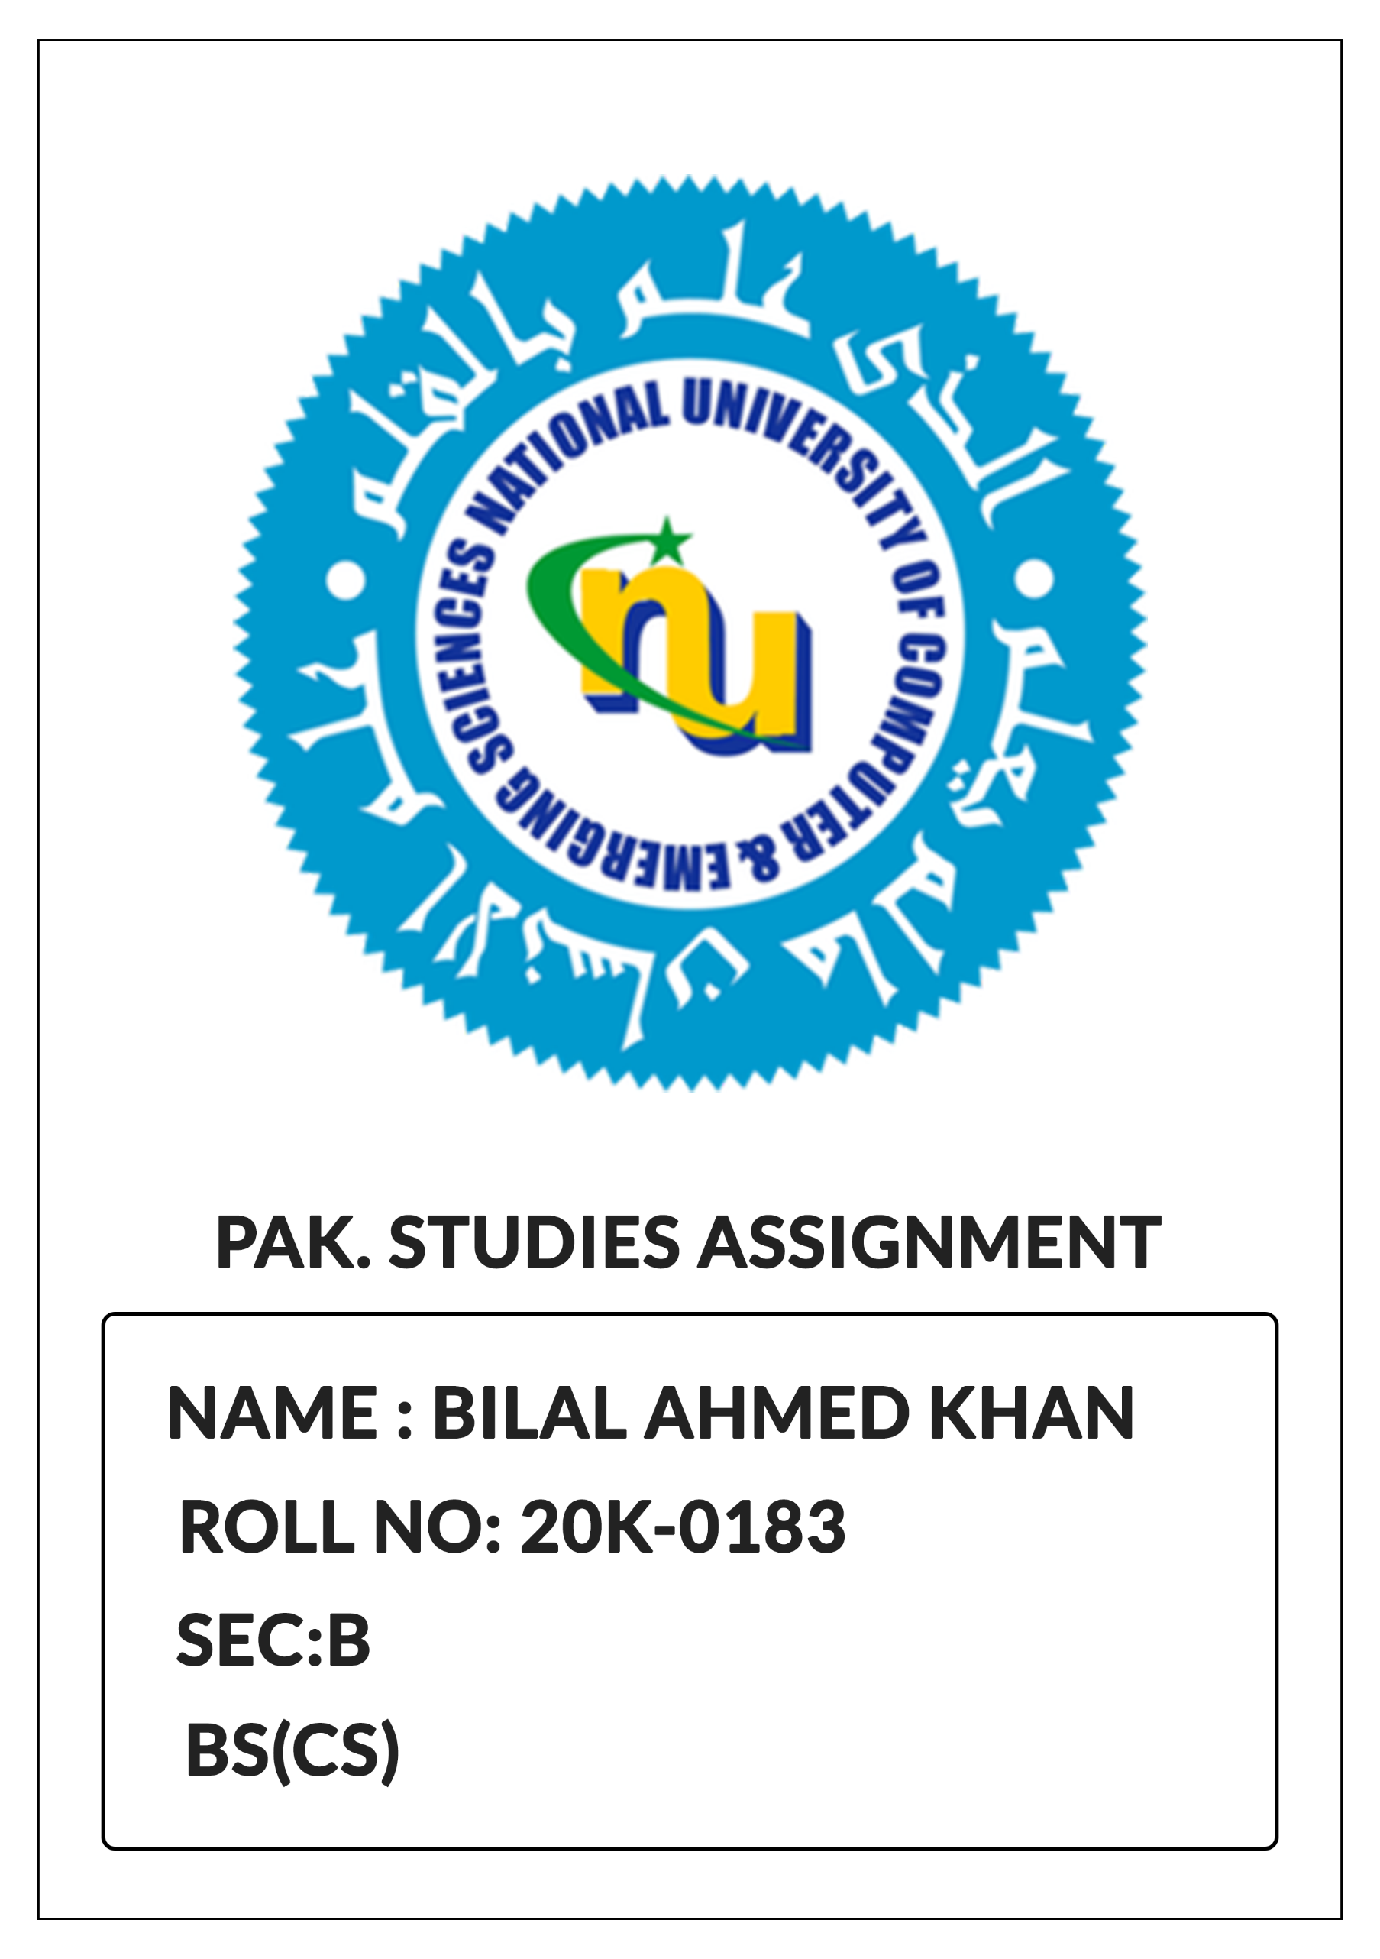

**War of Independence 1857:**

An artist's depiction of the 1857 war

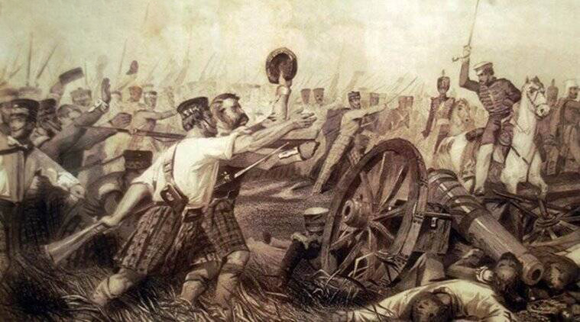

A number of factors contributed to the infamous War of Independence 1857 (also known as the Revolt of 1857). Some of the major factors are:

1. **Military:**

At the time of war of independence there were about 31,500 soldiers in the British army among which 51,000 were Britishers while the rest of the army men were native people of the subcontinent.

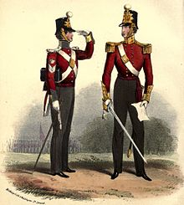British allocated about half of the budget for the British officers who were far less in number compared to the local soldiers. This created a sense of divide in the army.

The British Army

1. **Religious:**

Religious differences also played their part in the Revolt. The Brits wanted to convert sub-continent into a Christian State and sent Christian missionaries to the sub-continent. This also created a sense of insecurity in the local people.

Moreover, the Muslim and Hindu soldiers also refused to used the Enfield musket which used cow or pig’s fat because cow was a sacred animal for Hindus while Pig was Haram for Muslims.

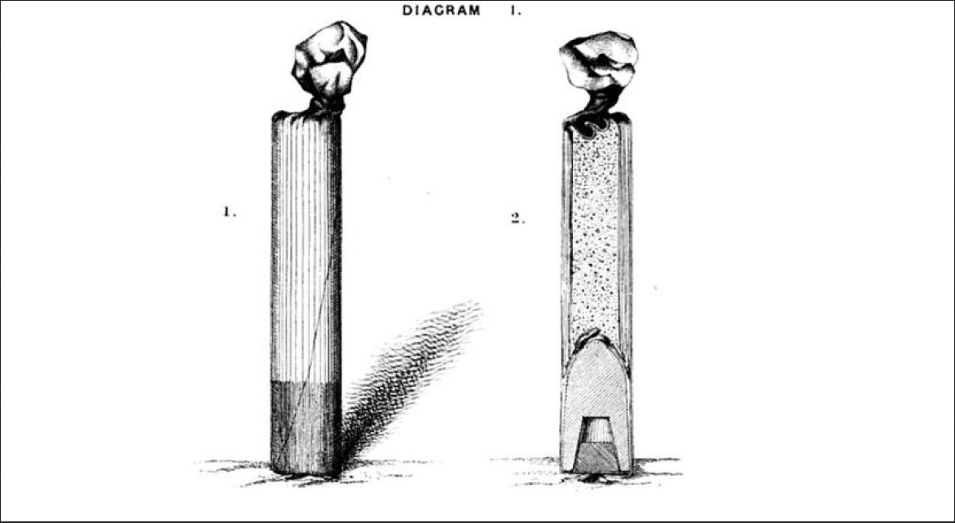

The Enfield Musket

1. **Political:**

Before the Brits came into power the subcontinent was ruled by the Mughals. Hence the local people had a sentiment of deprivation that the Britishers had deprived them of their right to rule.

1. **Doctrine of Lapse:**

The British introduced the DOCTRINE OF LAPSE under which the small states after the death of their ruler were forcefully occupied by the British Empire if the ruler didn’t had a son. A number of small states such as Awadh and Jhansi were lost because of this Doctrine.

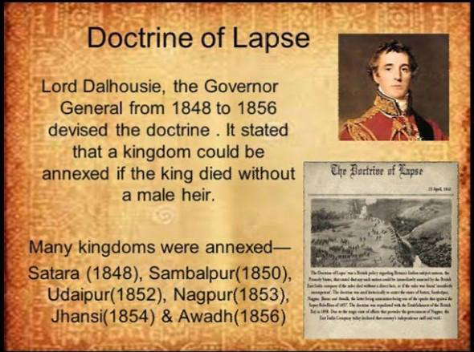**Economic Cause:**

Lord Dalhousie: The devisor of the doctrine of Lapse

The British also implemented high tax policies for the people of the subcontinent. Such high tariffs contributed to the feeling of resentment in the locals against the British Empire.

The British also started to move the wealth of the subcontinent to other colonies hence making the subcontinent much poor. According to some Economic experts about 45 trillion dollars were taken away from the subcontinent during the British Rule.

**Causes of Failure of 1857 War:**

The people lost the war of independence 1857 because of the following reasons:

1. **Lack of Leadership**

There was no central leadership of the people fighting and the emperor Bahadur-shah Zafar was too old to lead an army in a war.

1. **Lack of Transport Facilities:**

The people of India were ill equipped and didn’t had the latest and best equipment to fight British Soldiers. Moreover, the local people suffered a lot to lack of transport facilities.

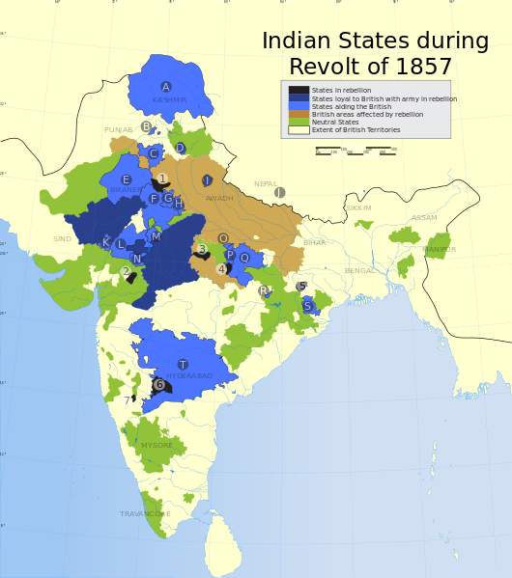

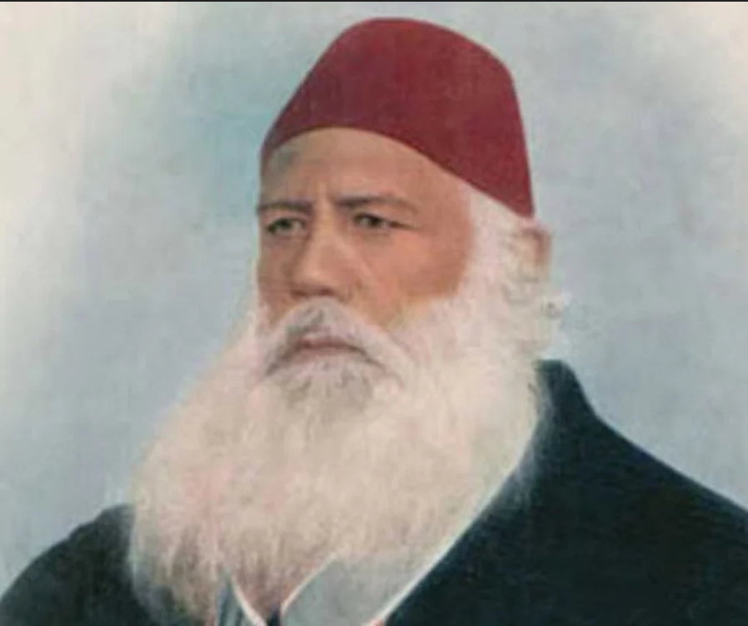**Sir Syed Ahmed Khan:**

Sir Syed Ahmed Khan

**Services of Sir Syed Ahmed Khan:**

1. **The Muslim Renaissance:**

Sir Syed played a major part in uplifting Muslims from their deplorable situation after the war of 1857. He made them realize that unless they equip themselves with modern knowledge the Hindus and British will continue their persecution.

1. **Ali Garh University:**

To further strengthen his mission of education he established the Mohammad Anglo Oriental College where Muslim students got modern education and made themselves capable of competing with the Hindus for Govt. jobs.

Later on, MAO College was converted into Ali Garh University which played a key role in the Pakistan Movement many students such as:

* Khuwaja Nizam-ud-din
* Liaqat Ali Khan
* Malik Ghulam Mohammad
* Fazal Ilahi Choudhary

were the alumni of Ali Garh University.



Ali Garh Muslim University

1. **Ghazipur Scientific Society:**

Sir Syed also established a scientific society at Ghazipur which translated the last scientific works of English in Urdu Language so that the masses could also benefit from modern research and the language barrier can be broken.